**Web Development CSS Major Project**

Now that you have learned most of the things in CSS, its time for your Major Project!

You have to build screens for a Music Player( we will be working on this Music Player in Javascript as well). You need to create everything from scratch using HTML and CSS and are **not supposed to use Bootstrap or any other frontend framework.**

You can visualize the rest from the images that are provided below.

Home Screen Image - 1

**[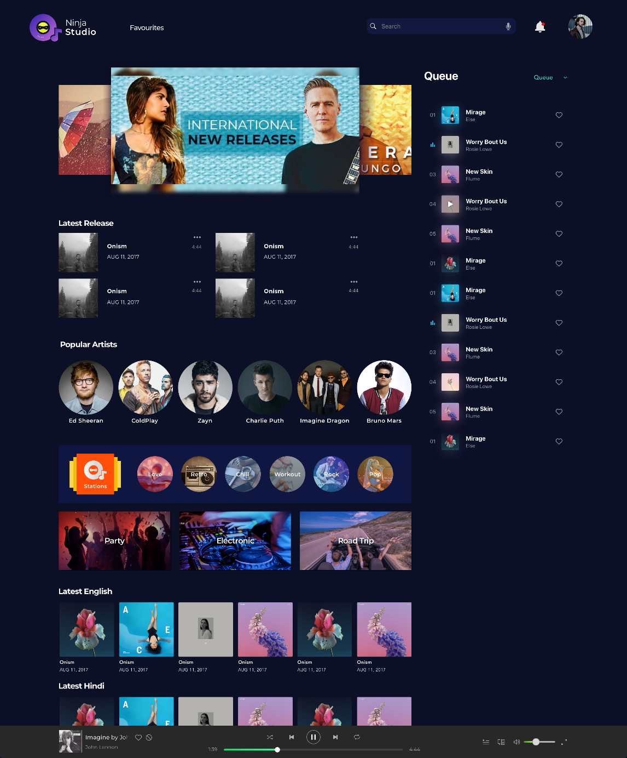](https://ninjasfiles.s3.amazonaws.com/0000000000001805.png)**

Home Screen Image - 2 (Playlist Dropdown)

**[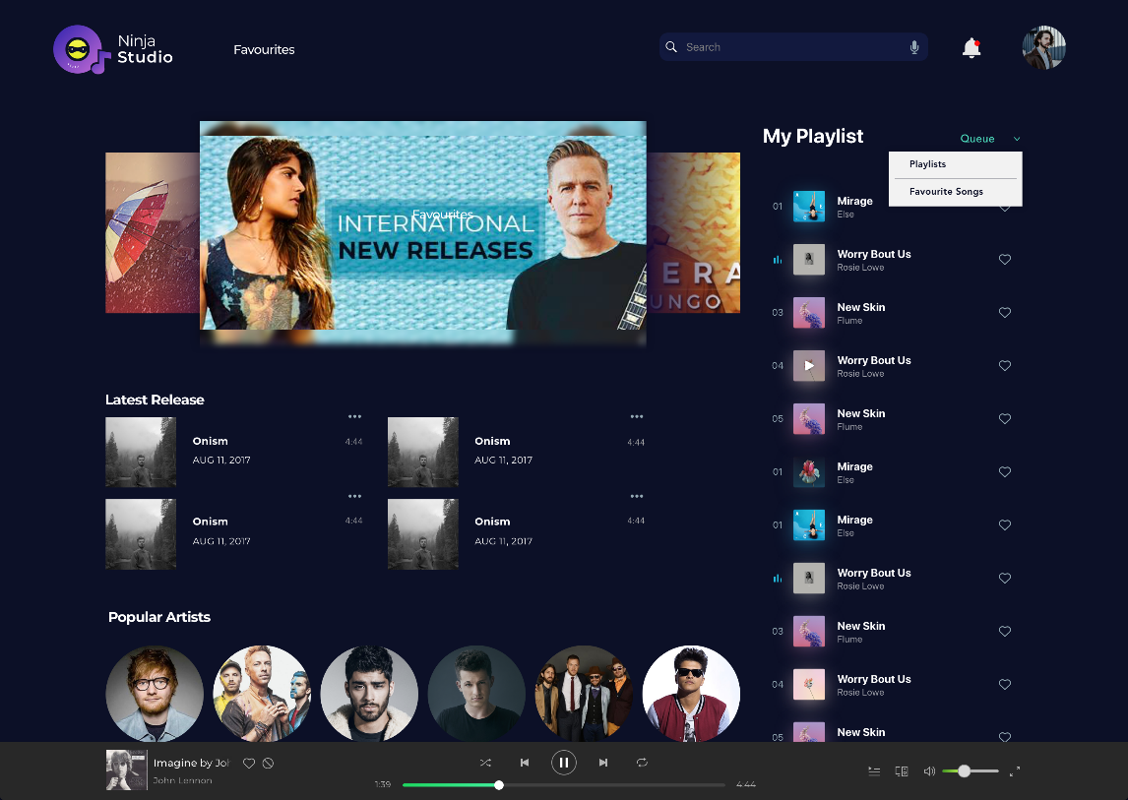](https://ninjasfiles.s3.amazonaws.com/0000000000001806.png)**

Single Playlist Screen

**[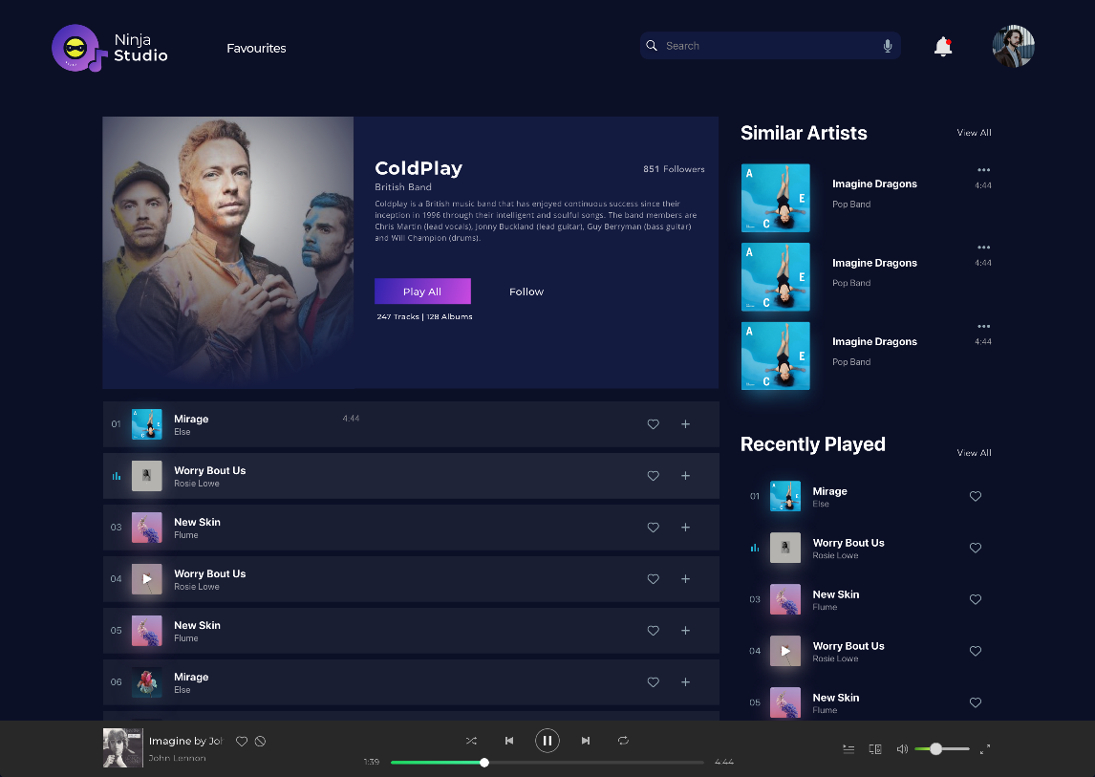](https://ninjasfiles.s3.amazonaws.com/0000000000001807.png)**

Remember that there are more than one ways to build a web page, so don't hesitate to try things on your own and explore new things online if you get stuck anywhere. That will help you to enhance your knowledge.

Take care of following points -

1. Home Screen Carousel - Try creating home screen carousel using CSS. For now it will be with dummy images, but ensure the functionality.

2. Code Quality - Ensure good code quality in terms of using classes, proper names for classes/variables, neatness of code and less redundant code.

3. Comments - You should add proper comments to the files, where you feel. This will improve readability of your code and will also help Teaching Assistants to understand it better.

4. Innovation - Although you are given basic template, feel free to explore more and add interesting features to your Music Player. You can also try different themes for the player(CSS Variables will help!)

Once you complete and submit your project, you will be scored according to the parameters provided below.

**Your project will be evaluated on following parameters -**

• Innovation (Max Score 10)

• Comments - Proper Comments should be added (Max Score 10)

• Code Quality - Avoid redundancies, Proper use of classes and Neat code (Max Score 10)

• Responsive Design (Max Score 10)

• Single Playlist Screen (Max Score 20)

• Bottom Music Player (Max Score 10)

• Home Screen Carousel (Max Score 10)

• Home Screen Basic Layout (Max Score 20)